Computer Architecture Lab
(EL-2012)
LABORATORY REPORT

Fall 2026

(Lab#01)
INTRODUCTION TO VERILOG

Student Name: M SHAFAY UL HASSAN_ Roll No: 24I-6552 Section: CE-A__

Date performed: 18-08, 2026

MARKS AWARDED: ________ / 10

Signature and date of Instructor: _________________
Lab Instructors: Dr. Nasir Ali Shah, Engr. Fasih Ahmad

______________________________________________________________________________________________________________________________________________________

NATIONAL UNIVERSITY OF COMPUTER AND EMERGING SCIENCES, ISLAMABAD
Prepared by: | Fasih Ahmad |  | Version: 1.0
Verified by: | Dr. Nasir Ali Shah |  | Updated: Fall 2026

Task 1:

Description:
Implemented the 7 basic gates with the Gate Level approach. Gate Level approach is that you have to implement the gates with the gates keyword like and,or,not etc.
Code:
module AND_gate(a,b,c); //AND Gate
input a;
input b;
output c;
and chk(c,a,b);

endmodule
module AND_test_bench();// the input vars would be of reg type and the output vars would be of wire type
reg x;
reg y;
wire z;
AND_gate uu(.a(x),.b(y),.c(z));
initial
begin
x=0;y=0;
#50 x=1;y=0;
#50 x=0;y=1;
#50 x=1;y=1;
end
endmodule
// OR Gate
module OR_gate(a,b,c); //or Gate
input a;
input b;
output c;
or chk(c,a,b);

endmodule
module OR_test_bench();// the input vars would be of reg type and the output vars would be of wire type
reg x;
reg y;
wire z;
OR_gate uu(.a(x),.b(y),.c(z));
initial
begin
x=0;y=0;
#50 x=1;y=0;
#50 x=0;y=1;
#50 x=1;y=1;
end
endmodule
//not gate
module NOT_gate(a,c); //AND Gate
input a;
output c;
not chk(c,a);

endmodule
module NOT_test_bench();// the input vars would be of reg type and the output vars would be of wire type
reg x;
wire z;
NOT_gate uu(.a(x),.c(z));
initial
begin
x=0;
#50 x=1;
end
endmodule
//NoR Gate
module NOR_gate(a,b,c);
input a;
input b;
output c;
nor chk(c,a,b);

endmodule
module NOR_test_bench();// the input vars would be of reg type and the output vars would be of wire type
reg x;
reg y;
wire z;
NOR_gate uu(.a(x),.b(y),.c(z));
initial
begin
x=0;y=0;
#50 x=1;y=0;
#50 x=0;y=1;
#50 x=1;y=1;
end
endmodule
//XOR Gate
module XOR_gate(a,b,c);
input a;
input b;
output c;
xor chk(c,a,b);

endmodule
module XOR_test_bench();// the input vars would be of reg type and the output vars would be of wire type
reg x;
reg y;
wire z;
XOR_gate uu(.a(x),.b(y),.c(z));
initial
begin
x=0;y=0;
#50 x=1;y=0;
#50 x=0;y=1;
#50 x=1;y=1;
end
endmodule
//NAND Gate
module NAND_gate(a,b,c);
input a;
input b;
output c;
nand chk(c,a,b);

endmodule
module NAND_test_bench();// the input vars would be of reg type and the output vars would be of wire type
reg x;
reg y;
wire z;
NAND_gate uu(.a(x),.b(y),.c(z));
initial
begin
x=0;y=0;
#50 x=1;y=0;
#50 x=0;y=1;
#50 x=1;y=1;
end
endmodule
// XNOR Gate
module XNOR_gate(a,b,c);
input a;
input b;
output c;
xnor chk(c,a,b);

endmodule
module XNOR_test_bench();// the input vars would be of reg type and the output vars would be of wire type
reg x;
reg y;
wire z;
XNOR_gate uu(.a(x),.b(y),.c(z));
initial
begin
x=0;y=0;
#50 x=1;y=0;
#50 x=0;y=1;
#50 x=1;y=1;
end
endmodule

Output:
AND Gate:
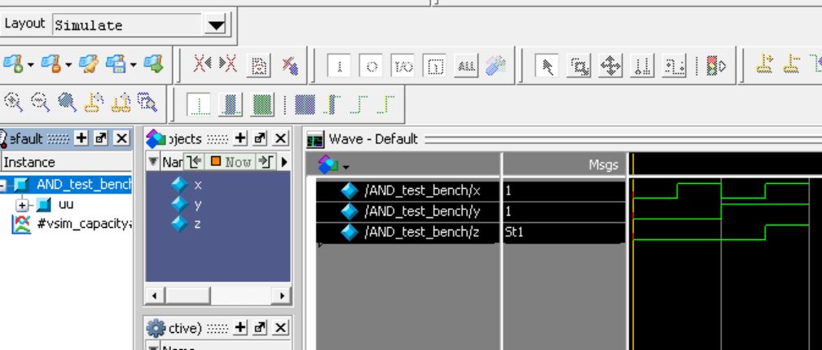
OR Gate:
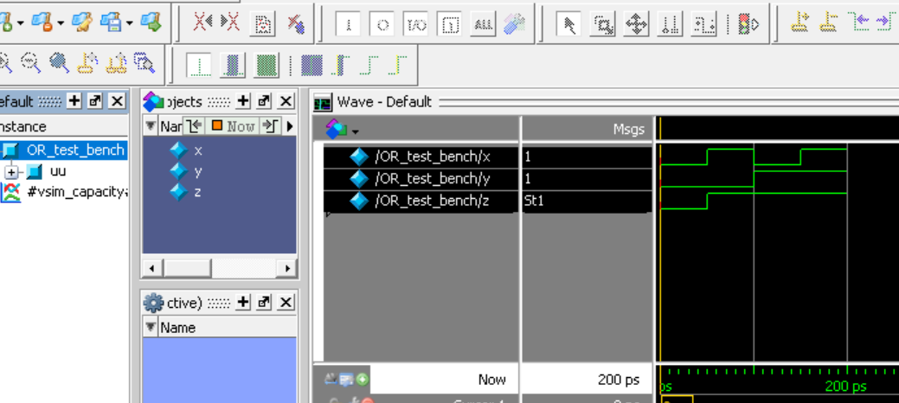
NOT Gate:
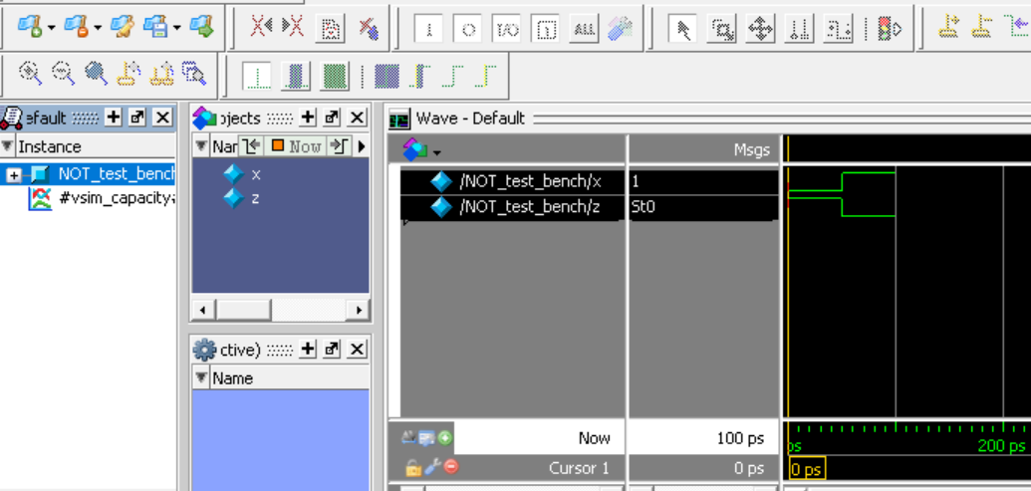
NOR Gate:
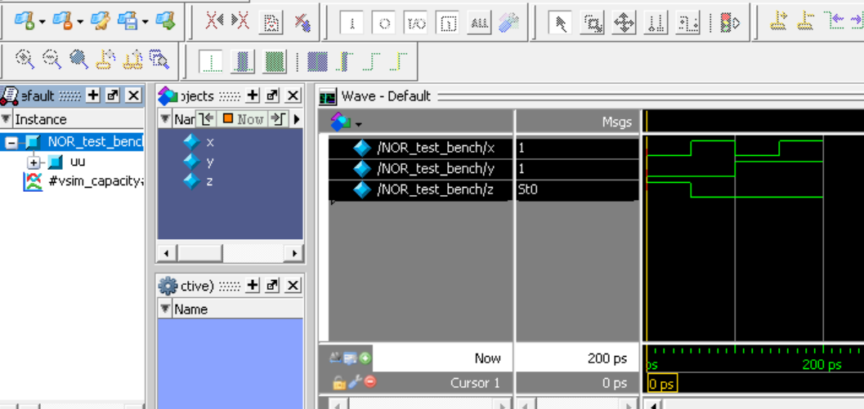
XNOR Gate:
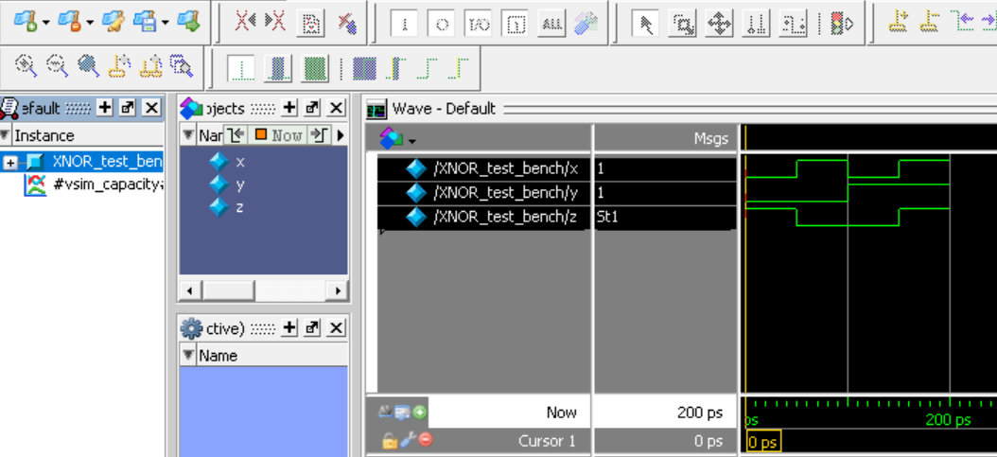
NAND Gate:
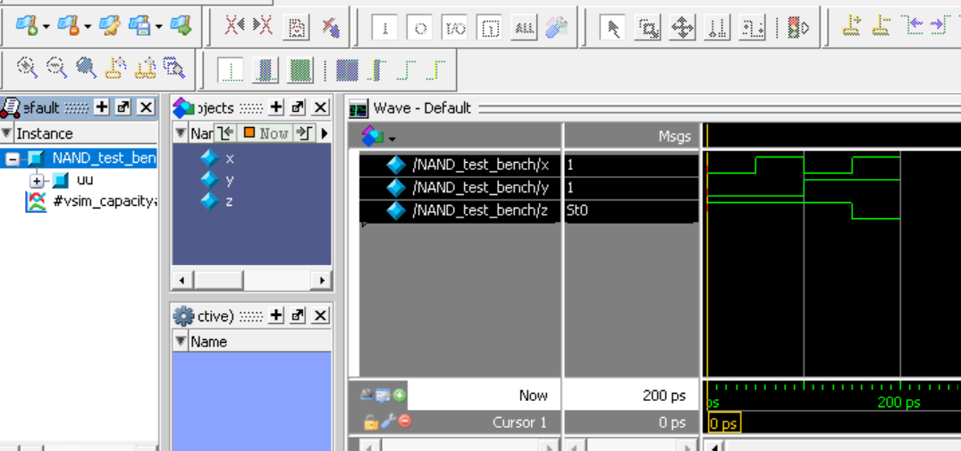
XOR Gate:
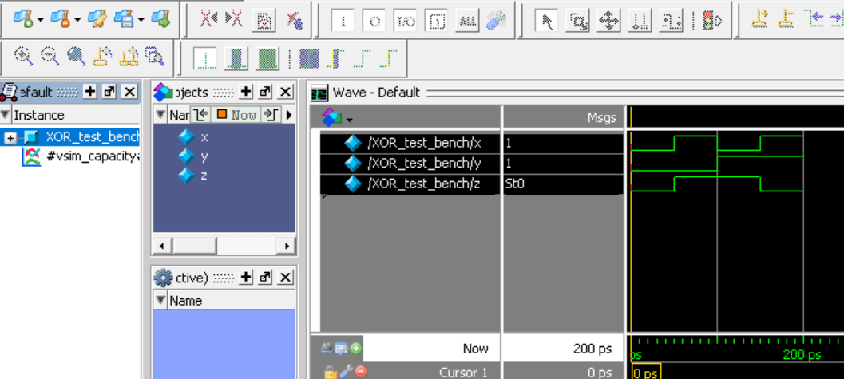
Task 2:

Description:
Implemented the 7 basic gates with the Data Flow Level Approach Data Flow Level approach is that you have to implement the gates with the assign keyword like assign c=a&b.
Code:
module data_OR_gate(a,b,c); //or Gate
input a;
input b;
output c;
assign c=a|b;

endmodule
module data_OR_test_bench(); // the input vars would be of reg type and the output vars would be of wire type
reg x;
reg y;
wire z;
data_OR_gate uu(.a(x),.b(y),.c(z));
initial
begin
x=0;y=0;
#50 x=1;y=0;
#50 x=0;y=1;
#50 x=1;y=1;
end
endmodule
//and Gate
module data_AND_gate(a,b,c);
input a;
input b;
output c;
assign c=a&b;

endmodule
module data_AND_test_bench();// the input vars would be of reg type and the output vars would be of wire type
reg x;
reg y;
wire z;
data_AND_gate uu(.a(x),.b(y),.c(z));
initial
begin
x=0;y=0;
#50 x=1;y=0;
#50 x=0;y=1;
#50 x=1;y=1;
end
endmodule
//not Gate
module data_NOT_gate(a,c);
input a;
output c;
assign c=~a;

endmodule
module data_NOT_test_bench();// the input vars would be of reg type and the output vars would be of wire type
reg x;
wire z;
data_NOT_gate uu(.a(x),.c(z));
initial
begin
x=0;
#50 x=1;
#50;
end
endmodule
//NOR Gate
module data_NOR_gate(a,b,c);
input a;
input b;
output c;
assign c=~(a|b);

endmodule
module data_NOR_test_bench();// the input vars would be of reg type and the output vars would be of wire type
reg x;
reg y;
wire z;
data_NOR_gate uu(.a(x),.b(y),.c(z));
initial
begin
x=0;y=0;
#50 x=1;y=0;
#50 x=0;y=1;
#50 x=1;y=1;
end
endmodule
//XOR Gate
module data_XOR_gate(a,b,c);
input a;
input b;
output c;
assign c=a^b;

endmodule
module data_XOR_test_bench();// the input vars would be of reg type and the output vars would be of wire type
reg x;
reg y;
wire z;
data_XOR_gate uu(.a(x),.b(y),.c(z));
initial
begin
x=0;y=0;
#50 x=1;y=0;
#50 x=0;y=1;
#50 x=1;y=1;
end
endmodule
//Nand Gate
module data_NAND_gate(a,b,c);
input a;
input b;
output c;
assign c=~(a&b);

endmodule
module data_NAND_test_bench();// the input vars would be of reg type and the output vars would be of wire type
reg x;
reg y;
wire z;
data_NAND_gate uu(.a(x),.b(y),.c(z));
initial
begin
x=0;y=0;
#50 x=1;y=0;
#50 x=0;y=1;
#50 x=1;y=1;
end
endmodule
//XNOR Gate
module data_XNOR_gate(a,b,c);
input a;
input b;
output c;
assign c=~(a^b);

endmodule
module data_XNOR_test_bench();// the input vars would be of reg type and the output vars would be of wire type
reg x;
reg y;
wire z;
data_XNOR_gate uu(.a(x),.b(y),.c(z));
initial
begin
x=0;y=0;
#50 x=1;y=0;
#50 x=0;y=1;
#50 x=1;y=1;
end
endmodule

Output:
AND Gate:

OR Gate:

NOT Gate:

NOR Gate:

XNOR Gate:

NAND Gate:

XOR Gate:

Task 3:

Description:
Implemented the gate level and data flow level of Verilog codes of the first task in logeism to verify the results in both the logism and modelsim . This technique is very useful to verify your results.
Output:
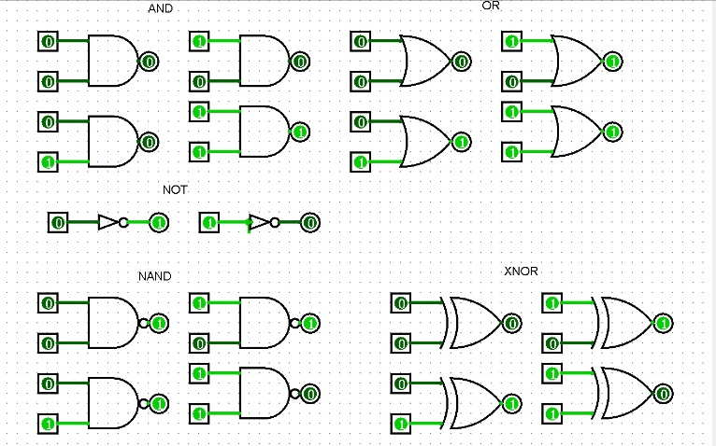
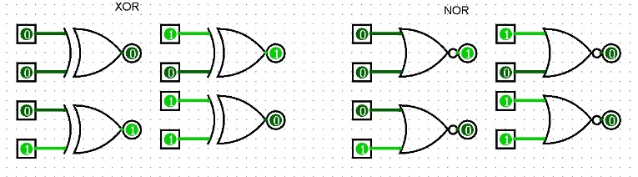

Task 4:

Description:
Implemented the 7 basic gates with the Data Flow Level Approach Data Flow Level approach is that you have to implement the gates with the assign keyword like assign c=a&b.Solved the complex circuit by using wires and output and input keywords .

Code:
module comp_big(a,b,out);
input a;
input b;
output out;
wire t1;
wire t2;
wire ta;
wire tb;
not temp1(t1,a);
and temp2(ta,t1,b);
not temp3(t2,b);
and temp4(tb,a,t2);
or tt(out,ta,tb);
endmodule
module test_bench04();
reg x;
reg y;
wire z;
comp_big tt(.a(x),.b(y),.out(z));
initial
begin
x=0;y=0;
#50 x=1;y=0;
#50 x=0;y=1;
#50 x=1;y=1;
#50;
end
endmodule
Output:
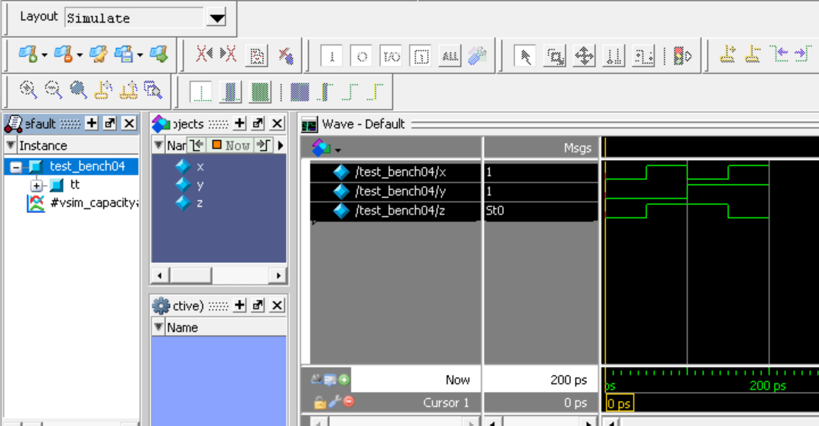
Task 5:

Description:
Implemented the gate level and data flow level of Verilog codes of the first task in logeism to verify the results in both the logism and modelsim . This technique is very useful to verify your results .

Output:
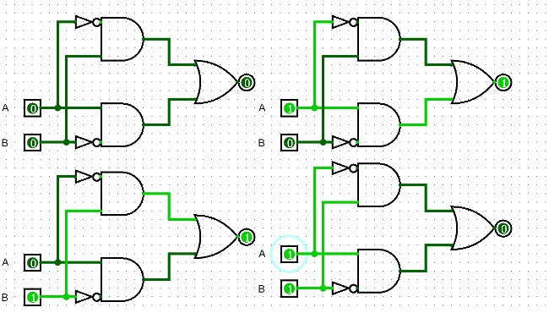

Task 6:

Description:
Implemented the gate level approach to solve the one`s compliment problem by taking the 4 inputs and 4 outputs and check the result using the waveforms .Also used wires in the test bench for the simulation results.
Code:
module comp_big(a,b,out);
input a;
input b;
output out;
wire t1;
wire t2;
wire ta;
wire tb;
not temp1(t1,a);
and temp2(ta,t1,b);
not temp3(t2,b);
and temp4(tb,a,t2);
or tt(out,ta,tb);
endmodule
module test_bench04();
reg x;
reg y;
wire z;
comp_big tt(.a(x),.b(y),.out(z));
initial
begin
x=0;y=0;
#50 x=1;y=0;
#50 x=0;y=1;
#50 x=1;y=1;
#50;
end
endmodule
Output:
